Meta-analysis

Purpose of the activity:
• Acquiring the skills to understand the results of a meta-analysis

Utility:
• Understanding the results of meta-analyzes, for bibliographic documentation, and for performing meta-analyzes in systematic reviews, for the thesis, personal research, clinical practice.

Introduction
Meta-analyzes can be considered statistical methods to unite the results of several original studies that attempt to answer the same question in a unique result.
The meta-analyzes use an indicator called the effect size, which is calculated for each individual study, and then calculates an effect size of all the analyzed studies. This indicator may be: Odds ratio (English - OR), Relative Risk, Risk Ratio, the average or Percentage of a characteristic (including Sensitivity, Specificity, positive or negative Predictive Values), the difference between two averages or between two percentages, ....
The publishing bias is the non-inclusion in the meta-analysis or in the systematic report of some studies that have not been published, and this may lead to distortions and distance from the truth. It is possible to evaluate it with statistical tests, funnel plots - where it is suggested by an asymmetry. However, it is difficult to evaluate and the fact that there are often few studies, the strength of the tests that attempt to identify it and any method of evaluation is reduced (e.g. under 10 studies).
Heterogeneity. For the graphical evaluation of heterogeneity, the forest plot can be used - if the lines corresponding to the confidence intervals overlap, the homogeneity of the results is suggested, otherwise the heterogeneity of the results is suggested.
The inconsistency index I² can be used to assess the degree of heterogeneity between studies, values ​​close to 0% indicating low heterogeneity and values ​​close to 100% high heterogeneity. There are no clear delimitation ranges but, indicatively, the following guiding values ​​can be used, also taking into account the confidence interval of I² and the statistical test result for the heterogeneity assessment (Higgins JPT, Green S (editors). Cochrane Handbook for Systematic Reviews of Interventions Version 5.1.0 [updated March 2011]. The Cochrane Collaboration, 2011. Available from www.handbook.cochrane.org.):
- 0% - 40% - heterogeneity probably unimportant
- 30% - 60% - may suggest moderate heterogeneity
- 50% - 90% - may suggest important heterogeneity
- 75% - 100% - may suggest very important heterogeneity
The statistical test for heterogeneity should be interpreted with caution, as the number of studies in meta-analyzes is usually low and therefore the test strength is small. Therefore, instead of the threshold of statistical significance of 0.05, the significance threshold of 0.10 can be used.

Scenario:
You have noticed that you are sleeping very little lately, because you are going to bed too late. You read a piece of news stating that those who go to bed later have higher IQ. You are flattered by this information, but after looking for the source article, find out that it was an observational study, so your enthusiasm diminishes. Turning to the realism that characterizes you, you ask yourself whether the reduced sleep duration is a risk factor for death.
Thus you search on the internet. You find an article, a systematic review with meta-analysis. (Cappuccio FP, D'Elia L, Strazzullo P, Miller MA. Sleep duration and all-cause mortality: a systematic review and meta-analysis of prospective studies. Sleep. 2010 May;33(5):585-92. Review. PubMed PMID: 20469800; PubMed Central PMCID: PMC2864873.)
A funnel plot is presented in the article. The Egger test (for publishing bias) provided p = 0.74 for the distribution of the observed results (here the logarithm of the relative risk) depending on the size of the effect. This graph is used to identify the publishing bias. An important asymmetry suggests the possibility of a systematic publishing error. Studies with many subjects (the top ones) are close to the average, and those with few subjects being more distant, but approximately symmetrically distributed):
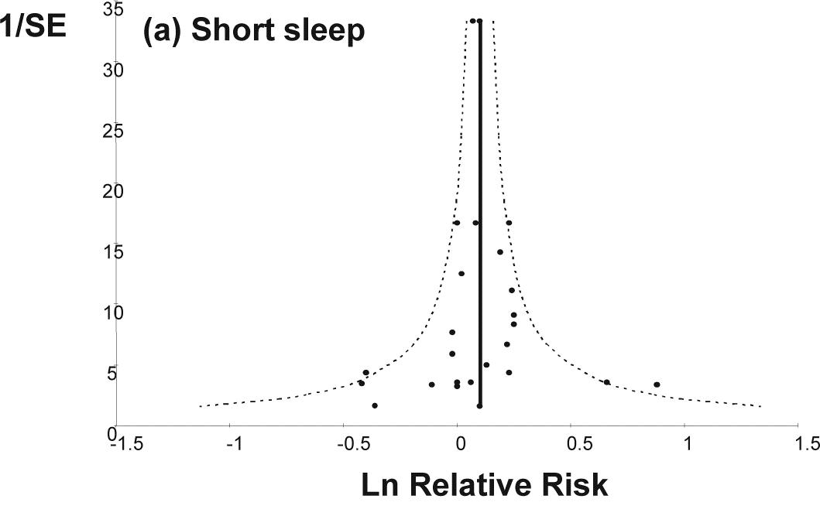
Fig. 1 Funnel chart for studies assessing the link between sleep deprivation and deaths

Specify if a marked asymmetry is noted in the funnel plot
• Yes / No

Specify if there is a significant evidence of systematic publishing error
• Yes / No

The forest plot is presented below - the relative risk of death associated with reduced sleep duration compared to a reference group in 25 cohorts of 15 published prospective studies, including 1,381,324 subjects and 112,163 deaths. The results are presented by relative risk (RR) with 95% confidence interval. The final result of the meta-analysis provided a P <0.01; And the heterogeneity test: I² = 39%, P = 0.02 - indicates whether the studies have discordant results - in case of heterogeneity, a meta-analysis take into account for these differences)
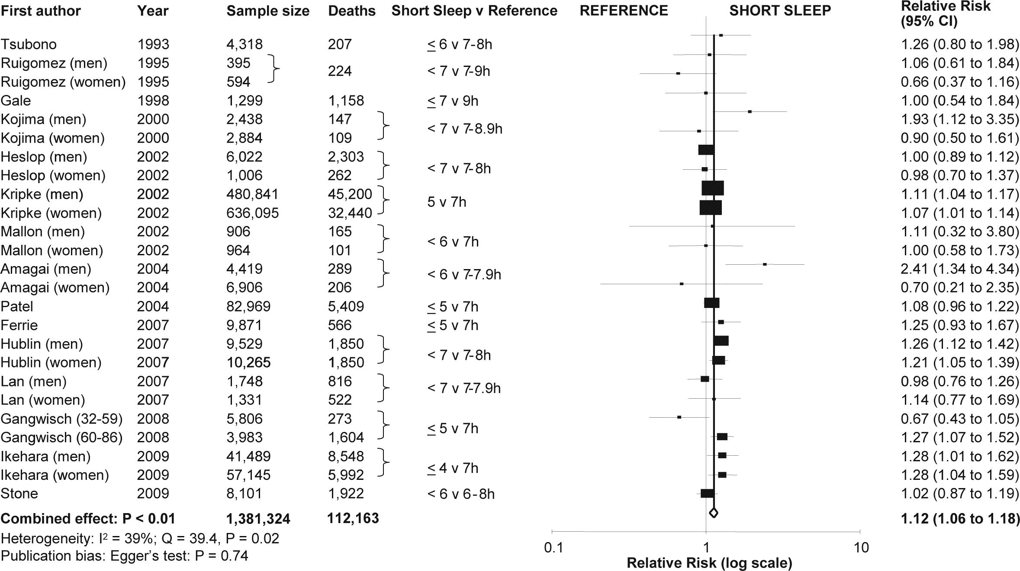
Fig. 2 Forest plot for studies assessing the link between sleep deprivation and death

Requirements:
Specify whether the heterogeneity of studies was statistically significant
• Yes / No
Respectively specify how important it is (based on I²)
• Not important / moderate / important / very important (see the Introduction)

Write if the precision of the outcome of the penultimate study, the men subgroup (Ikehara (men), 2009) is higher than the outcome of the penultimate study, the women subgroup (Ikehara (women), 2009)
• Yes / No

Specify if the outcome of the penultimate study, the women subgroup (Ikehara (women), 2009) was statistically significant (the confidence interval does not include 1)
• Yes / No

Write if the precision of the final (combined) result is better than the precision of the studies taken individually
• Yes / No

Interpret statistically the combined effect of the studies: RR = 1.12
•

Interpret statistically the confidence interval for the combined effect of RR: (95% CI 1.06 - 1.18)
•

Interpret clinically the combined effect of RR = 1.12
• Relatively low / moderate / important

Based solely on these results, there is a possibility that insufficient sleep is a cause of death (the study suggests that sleeplessness is a possible risk factor for death)?
• Yes / No

Note that the meta-analysis only included prospective observational studies. Can this meta-analysis prove without doubt that sleep deficiency is the cause of increased mortality?
• Yes / No

Based on these results only, do you have an undisputable argument to sleep more?
• Yes / No

Laboratory Conclusions: Today's work helps you
• Understanding the results of meta-analyzes, for bibliographic documentation, and for performing meta-analyzes in systematic reviews, for the thesis, personal research, clinical practice.

E-mail this Word document (after you fill it out, save and close it in advance) as an attachment.

In the email, specify in Subject: Contact details and title of the activity.

Copyright: Daniel-Corneliu Leucuţa

ț

