THE BIBLIOGRAPHIC STUDY / LITERATURE REVIEW

Introduction:
Preparing the research for your license thesis will have to start by reviewing scientific literature about the subject of your future research. This mandatory phase of any research project is called a bibliographic study. It helps you to justify your research, adds to your previous knowledge about the subject of your research and gives you a place to start and to learn from the experience of peer researchers and practitioners.
Later on, when writing your license thesis, knowledge that emerged from your bibliographic study, will be a key component in order to introduce the subject of your research to your readers, by picturing the level of knowledge in the given field of investigation. This, again, represents a mandatory step when writing a thesis or other academic papers. While papers presenting original research will use such information when writing their introductory chapter, license theses must allocate to this purpose an even larger amount of space, in a separate chapter dedicated to stating the current level of knowledge in the field. You will also use information emerging from one or several bibliographic studies (literature reviews) in order to refer to methods previously employed by other authors, as well as to relate to other author’s research results. As a future practitioner, you should perform literature reviews whenever a puzzling clinical question arises in your practice. This is an important part of evidence based medicine/dentistry (EBM/EBD).
Concretely, after having set a provisional or definitive title for your thesis, you need to review scientific papers, books and other relevant literature about the subject of your future research. Whenever you will find relevant pieces of information, which you think you may use to present the current level of knowledge in the field or to justify certain future statements you will be making in your thesis, it is highly recommended to safeguard such information together with all necessary identifiers of their source, in order to avoid searching all over again for those pieces of information when you will need to give credit to their authors by citing them as references of your thesis. Safeguarding such information can be done by creating a bibliographic record for each relevant paper or book that you have found. Several bibliographic records should be grouped to form a bibliographic catalog that may be consulted later on, in order to quickly retrieve necessary data when citing the work of other authors and writing the references list of your thesis.
You should start your literature review by reading books about the chosen subject, from your personal library, from the library of the department coordinating your thesis, from our University library (http://www.umfcluj.ro/ro/educatie-ro/reurseedu-ro/biblioteca-ro) or from the internet (http://www.freebooks4doctors.com/).
After having broadly understood the subject of your future research, you should continue by looking for recent developments in the field. To do that, you should search for published papers and reviews in medical journals that you may access at the University library (http://www.umfcluj.ro/ro/component/k2/item/1178-abonamente-curente ) or over the internet (www.pubmed.com , http://www.freemedicaljournals.com/ , http://scholar.google.com/).
Over 24,000,000 titles of scientific papers published worldwide in more than 6000 medical journals are indexed in Medline, the abstracts of most being accessible by using PubMed, a service of the U.S. National Library of Medicine. Over 9,000,000 of these articles are also available in full text, of which 500,000 free of charge.
Relevant articles that are not free of charge may be searched for in the inventory of our University library. If still not found, students and staff of our University may order academic articles at significantly lower rates than those stated on the web by their publishers, using the ordering service provided by our University library (http://www.bib.umfcluj.ro/bibumf/expres/user.aspx).

Aims of this practical session:
- acquiring basic skills for searching original articles and review articles using PubMed
- creating a Word file and its table of contents, as a simplified bibliographic catalog, in order to organize and easily retrieve relevant articles on a given subject

Utility:
- tools for performing the literature review for your graduation thesis
- tools for performing the literature review before and during any scientific research

Requirements

1) Searching in bibliographic databases
Utility: answering specific questions
Advantages: finding the most recent/up to date information
Examples of databases in our university computer network:
  - medical: www.pubmed.gov, www.embase.com, systematic reviews: thecochranelibrary.org
  - general (non medical specific): www.sciencedirect.com, www.springerlink.com, onlinelibrary.wiley.com/, www.scopus.com,

1.1) Searching for clinical information
Databases: Pubmed (www.pubmed.gov) by using Clinical Queries (http://www.ncbi.nlm.nih.gov/pubmed/clinical).

1.1.1) Searching for therapy information:
Scenario: you are a student in the last year of the faculty. For your license thesis you have a chapter, where you want to write if in subjects with heart failure bisoprolol is better than carvedilol in respect of mortality
Method: we will use PICO method to create specific questions: P –the Patient/the problem to deal with (usually the name of the disease), I – the intervention that we are interested in using to deal with the problem (e.g. a drug), C – the Comparison intervention, the intervention with which we want to test against, it can be optional (e.g. another drug), O – the Outcome (what we want to achieve with the interventions).
Requirements:
- write the search strategy (the 4 components of PICO for the scenario):
- P: I: C: O:
- Search for results by using Clinical Study Categories, the therapy option (Therapy), with the option to find many results (Broad) and write how many results you found (Results)
- Number of results:
- Search for results by using Clinical Study Categories, the therapy option (Therapy), with the option to find fewer results (Narrow) and write a title of an scientific article that answers your question:
- Number of results:
- Title:
- for the section Systematic Reviews write how many results did you found (Results) and then open the following article (in italics). For this article write how many studies (randomised trials) the researchers assessed, and the conclusion of the article: Comparison of the beneficial effect of beta-blockers on mortality in patients with ischaemic or non-ischaemic systolic heart failure: A meta-analysis of randomised controlled trials (link direct).
- Number of results (systematic reviews):
- Number of studies (in the Results section of the abstract):
- The conclusion of the article:
To see the full text of the article click on LinkOut – more resources – there will be one or more links to the full text (e.g. Wiley, EBSCO – these companies can change in time depending on who is providing the journal. If the University has a contract with them, then the article will be available for free within its network)

1.1.2) Searching for diagnosis information:
Scenario: you are a medical doctor in your residency. You have to do a presentation about the imagistic diagnosis in Alzheimer Disease. For this presentation you search Pubmed for possible differences between Single-Photon Emission-Computed Tomography and Magnetic Resonance Imaging. You are interested to see if the sensitivity of these two techniques is different.
Method: we will use PICO method to create specific questions: P –the Patient/the problem to deal with (usually the name of the disease), I – the intervention that we are interested in using to deal with the problem (e.g. a diagnosis technique), C – the Comparison intervention, the intervention with which we want to test against, it can be optional (e.g. another diagnosis technique), O – the Outcome (what we want to achieve with the interventions).

Requirements:
- write the search strategy (the 4 components of PICO for the scenario):
- P: I: C: O:
- Search for results by using Clinical Study Categories, the diagnosis option (Diagnosis), with the option to find many results (Broad). Write how many results you found (Results) and a title of a scientific article that answers your question.
- Number of results:
- Title:
- for the section Systematic Reviews write how many results did you found (Results) and then open the following article (in italics). For this article write how many studies the researchers assessed, and the conclusion of the article: Fluorodeoxyglucose-positron-emission tomography, single-photon emission tomography, and structural MR imaging for prediction of rapid conversion to Alzheimer disease in patients with mild cognitive impairment: a meta-analysis (link direct).
- Number of results (systematic reviews):
- Number of studies (in the Results section of the abstract):
- The conclusion of the article:
To see the free full text of the article click on the image in the top right of the abstract that contains the word FREE.

1.1.3) Searching for prognosis (risk factors) information:
Scenario: you are a student. A person close to you just had a dental implant. You know that this person is smoking. You think that it is possible that smoking can affect the implant so that the implant will have a failure in time.
Method: we will use PICO method to create specific questions: P –the Patient/the problem to deal with (usually the name of the disease), I – the intervention that we are interested in using to deal with the problem (e.g. a risk factor), C – the Comparison intervention, the intervention with which we want to test against, here it is optional, O – the Outcome (what we expect to happen – e.g. a complication due to the risk factor).
Requirements:
- write the search strategy (the 3 components of PICO for the scenario):
- P: I: O:
- Search for results by using Clinical Study Categories, the prognosis option (Prognosis), with the option to find many results (Broad). Write how many results you found (Results).
- Number of results:
- Search for results by using Clinical Study Categories, the prognosis option (Prognosis), with the option to find fewer results (Narrow) and write a title of an scientific article that answers your question.
- Number of results:
- Title:
- for the section Systematic Reviews write how many results did you found (Results) and then open the following article (in italics). For this article write how many studies the researchers assessed, and the conclusion of the article: Smoking interferes with the prognosis of dental implant treatment: a systematic review and meta-analysis (link direct).
- Number of results (systematic reviews):
- Number of studies (in the Results section of the abstract):
- The conclusion of the article:

2) Searching for books
Utility: to answer to general/broad questions (e.g. a disease/a medical problem)
Disadvantages: the information is not up to date, even if the books are new
To search for books in the UMF Cluj library:
  - Internet access to the book search engine : http://www.liberty.umfcluj.ro

Scenario: You are a student. Your license thesis is in the microbiology field. You think to search for a microbiology book to get a structured picture of some topics you will write in your thesis. You heard about a book of someone called Burton (Burton’s Microbiology or something like this but the title was longer). You are interested to see if the book can be found in the library.
Technique: use the link for the UMF Cluj library search engine: http://www.liberty.umfcluj.ro/liberty/libraryHome.do
You can select Căutare avansată (advanced search), type the words that you know from the title in the title fiels, and the name of the author in the author field, then press the green buton to search.
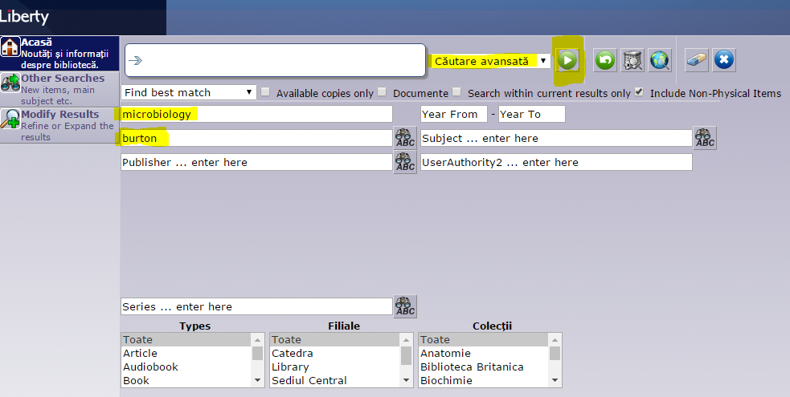

Requirements: write if you found the book in the library (yes/no)

Opt) Create a file of Bibliographic records, with articles that you found interesting in one of the above three searches on Pubmed. Copy those articles; add a table of contents to easily find relevant information. At the end of the file write an interesting piece of information you did find in one of the articles found, or write a conclusion of all the research.

Indications:
Repeat one of the above three searches on Pubmed.
After you consider your search strategy to have reached an optimal level of discrimination, read each article returned by your search strategy and select the most relevant 2 original researches and 2 reviews. Remember that at least 1 relevant article should be in free full-text.
Copy those 4 articles into a new Word document, while making sure to include all necessary data (authors, title, name of journal, year of publication, number of volume, number of issue, pages) that will allow you to cite those articles as references for your “thesis”. Save the new Word document on your disk partition, naming it “Bibliographic records”.

In order to create a table of contents for easy navigation and retrieval of bibliographic records inside your Word document, you will first need to eliminate all text formatting. This should be done since some formatting may interfere with the correct display of the table of contents.
To eliminate all formatting, select the whole document using Edit/Select All, cut it using Edit/Cut and paste it back in, using Edit/Paste Special/unformatted text.
Now select and mark all article titles using a Heading 1 style format.
Then, go to the first page of your document, insert a new page (Insert/Break/Page brake) and write the subject of your research on it, as a document title.
Below, insert the table of contents using the tab References/ Table of contents – the firs option.
Use the mouse-pointer and the table of contents to navigate to each article and mark (bold and underline) relevant information that contributes to partially or completely answering the question of your intended research.
On the same first page, write the answer to your question, as it results from your bibliographic study.

Conclusion:
Today’s activity helps you perform literature reviews for your graduation thesis, for other research projects, as well as for answering clinical questions in the context of evidence based medicine/dentistry (EBM/EBD).

Save the changes you made to both, this document and “Bibliographic records”, then close them.

Attach both Word documents to an e-mail message and send it to the address provided by your assisting professor. Specify in the e-mail Subject: Your full name, your group and the title of this activity.

