Recapitulative problems of medical research methodology

Utility:
- to rehearse basic knowledge of medical research methodology, which in turn helps you:

- to perform the research for your graduation thesis
- to answer clinical questions and to practice evidence based medicine/dentistry (E.B.M. / E.B.D.)
- to understand and critically appraise academic papers that you will read as part of your continuous medical education (C.M.E.)
- to understand and critically appraise oral presentations at congresses and other conferences that you will attend as part of your continuous medical education (C.M.E.)

Requirements:
Create a PowerPoint presentation entitled Recapitulative Problems, with a subtitle that should contain your full name, study year and group. Save this file on your partition, using the format LastName FirstName (ex. Schiller Friedrich).
The PowerPoint file should contain the solutions for the following problems:

- The link between fluoridation and tooth decay has been investigated in pre-school children. Two groups of children have been established and monitored between ages 2 and 6. The children in the first group came from kindergartens implementing an organized program of internal and external fluoridation. Children forming the second group came from a region with known insufficient fluoridation and they were not administered fluoride supplements. At age 6, children in both groups were evaluated regarding the number of caries. The presence of 3 or more dental caries at age 6 was considered an unfavorable outcome. The kindergartens were chosen to be representative to the target populations – with acceptable or lower fluoridation. The samples were well defined with inclusion and exclusion criteria. The children were introduced in the study only if they hadn’t tooth decay. The children were followed for 4 years. At the end of the study 70% of them were available for the final analysis. The sample with insufficient fluoridation had 97 children, of whom 25 had 3 or more dental caries at 6 years. The sample with sufficient fluoridation had 136 children, of whom 11 had 3 or more dental caries at 6 years. The 95% confidence interval to quantify the relationship between insufficient fluoridation and a high number of tooth decays was (95% CI 1.65 – 6.16)
  - Specify:
- [eliminatory] the domain of clinical research (Description of a new health phenomenon; Evaluation of a diagnostic procedure; Evaluation of a therapeutic approach; Evaluation of a risk or prognostic factor)
- the study type based on the researcher’s approach (Descriptive / Analytical)
- the study type based on the researcher’s role/intervention (Observational / Experimental). Please specify if a study like this one is sufficient to draw a definitive conclusions regarding causality between the risk factor and the disease
- the type of data collection based on the studied population (exhaustive/by sampling)
- the type of data collection based on its duration (Cross-sectional / Longitudinal [retrospective / prospective])
- the type of data collection based on the grouping method (representative sample, exposed/not exposed, case control)
  - Plot the contingency table for this study on a sheet of paper.
  - [eliminatory] Write down what medical indicator would you choose to quantify the relationship between the insufficient fluoridation and a high number of tooth decays. Compute it, and interpret it statistically and clinically.
  - [eliminatory]Write down the name of a statistical test to assess the relationship between the insufficient fluoridation and a high number of tooth decays. Write down the null and the alternative hypotheses of the test. If the p-value of the test is 0,0002, interpret the result of the test.
  - What type of table and what type of chart for description of the relationship between insufficient fluoridation and a high number of tooth decays would you recommend?
  - What type of table and what type of chart for description of the variable insufficient fluoridation would you recommend?
  - Is this study superior as quality to a case control study in the hierarchy of evidences?
  - What type of article is immediately below a systematic review of cohort studies on the hierarchy of evidences for a question in the prognostic domain?
  - Is this study valid? Write the criteria that shows the validity or absence of validity for this study.
  - How is the relative risc precision for this study (rather precise/less precise)? In your opinion, according to the 95% confidence interval presented in the study, how is the size of the groups? (rather small/ large)
  - Evaluate the confidence interval of the relative risk written in this study, in the clinical context (strong clinical significance/ weak clinical significance/ unclear clinical importance)
  - Interpret statistically the attributable risk value, and of its confidence interval. Their values are: 17.7% (95% CI 7.8% - 27.5%). State if the confidence interval of the medical indicator quantify what happens to patients from the study or from the target population.
  - You read an academic paper published in a printed medical journal. You have the following information about this article: title: The association between paternal prostate cancer and type 2 diabetes, publishing journal: J Carcinog, authors: Peter Meyer, Christine Zuern, Norbert Hermanns, Thomas Haak, year of journal publication: 2007, volume number: 6, extreme pages: from page 234 to page 239. Write the correct reference to cite the academic paper according to the Vancouver system.
  - Write down the search strategy to be used in Pubmed, by using the PICO technique, to search articles similar to this study. If you have a question in the prognosis domain, which is the first type of study that you need to look for in order to answer the question?
  - Assuming that most children who abandoned the study from the group with insufficient fluoride-intake were those with an unsatisfying level of oral hygiene, how do you think that this fact influenced the risk ratio obtained in this study compared to the true value of risk ratio? Is the study valid under the above assumption?

- You have evaluated a new diagnostic test (pulse palpation) by comparing it to a golden standard test (electro cardio gram test – the best test for the disease), to identify the presence of the disease of interest (atrial fibrillation), in a phase II evaluation. The reference test is the best one for the diagnostic of this disease. The same physician assessed the presence of the disease first with the reference test then with the new test. All the consecutive patients that presented to the hospital were included in the study. You have obtained the results in the following table:
 |  | Golden standard
 |  | diseased (D⁺) | non-diseased (D⁻)
New test | positive (T⁺) | 67 (80%) | 9 (2,5%)
New test | negative (T⁻) | 18 (10%) | 344 (97,5%)

  - Write the values for: real positives, real negatives, false positives, false negatives
  - [eliminatory] Name, write the formula and compute the probability of a patient who tested positive with the new test to have the tested disease. Interpret the result statistically.
  - [eliminatory] Name, write the formula and compute the probability of a non-diseased patient to test negative using the new test. Interpret the result statistically and clinically.
  - [eliminatory] Name, write the formula and compute the probability of a diseased patient to test positive using the new test. Interpret the result statistically and clinically.
  - [eliminatory] Name, write the formula and compute the probability of a patient who tested negative with the new test to not have the tested disease. Interpret the result statistically.
  - Write the formula and compute LR+ and LR-. Explain and interpret the statistical meaning of LR+.
  - You suspect one of your patients to have the disease tested by the new test. From anamnesis you assume a probability of 0.7 (70%) for your patient to have the disease. You apply the new test and your patient tests positive. Use Fagan’s nomogram to find the probability for your patient to actually have the tested disease.
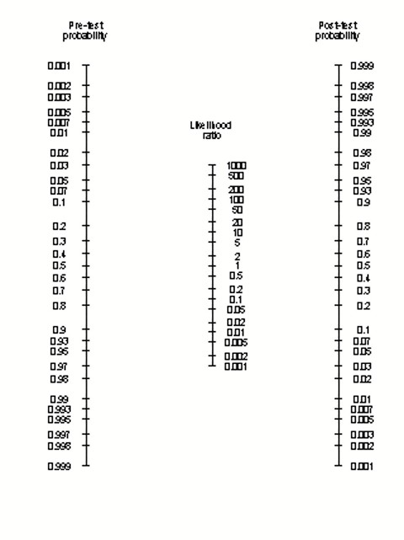
Figure 1. Fagan nomogram

  - Is this study valid? Write the criteria that shows the validity or absence of validity for this study.
  - Is this study superior to a systematic review of diagnostic studies of level 1b that assesses the same tests, on the hierarchy of evidences for a question in the diagnostic domain?
  - Write down the search strategy to be used in Pubmed, by using the PICO technique, to search articles similar to this study, articles that have as objective the assessment of sensitivity. Which is the first type of study that you need to look for in order to answer the question?
  - Write what's wrong in the above table from the scientific writing point of view (if applicable):
  - Specify:
- [eliminatory] the domain of clinical research
- the study type based on the researcher’s approach
- the study type based on the researcher’s role/intervention
- the type of data collection based on the studied population
- the type of data collection based on its duration
- the type of data collection based on the grouping method

- In a randomized clinical trial (RCT) a morphine-based anesthetic has been evaluated against placebo in mechanically ventilated premature babies, to determine the level of adrenaline in the blood of the babies and also the reduction of the pain symptoms. For the first 24 hours of treatment, the study reported babies who received the morphine-based anesthetic to exhibit a significantly lower adrenalin level in peripheral blood than babies who received placebo (mean difference of adrenalin levels between groups: 0.6 nmol/L, and the standard deviation was 0.05 nmol/L). All the subjects were assessed in this study (no subjects withdrawn). The analysis of the data was of the type intention to treat. The researcher that introduced the subjects in the study chose to give morphine especially to children with a low birth weight, and the placebo to children with a better birth weight. The results were assessed by a physician that wasn’t informed of the treatment allocation. The babies/parents didn’t know which of the two treatments they received. The two groups were similar as characteristics at the beginning of the study. From the point of view of the reduction of the symptoms due to morphine, compared to placebo, the results were: NNT=25, ARR=4%, et RR=1,2.
  - Is this study valid? Write the criteria that shows the validity or absence of validity for this study.
  - [eliminatory]Interpret NNT, ARR, and RR
  - [eliminatory]Write down what medical indicator would you choose to quantify the difference in results of the treatments (in respect of the reduction of the symptoms). Write the formula for this indicator.
  - [eliminatory] Write down the null and alternative hypotheses for this study in respect of the reduction of the signs/symptoms
  - [eliminatory] To test the hypothesis that there are differences between the mean of adrenaline in the group that received morphine and those that received placebo, the data being normally distributed, please state the type of the variable that is compared. Write down if the samples that are compared are dependent or independent. Write down the name of the statistical test that can be used here. If the p-value of the test is 0.50, interpret the result of the test.
  - What type of chart for description of the variable adrenaline level would you recommend?
  - Write down what percentage of the studied sample is within the mean of the difference of adrenaline level +/- one standard deviation.
  - Write down the search strategy to be used in Pubmed, by using the PICO technique, to search articles similar to this study. Which is the first type of study that you need to look for in order to answer the question?
  - A systematic review of randomized controlled trials that studies the same thing as this study is superior to this study, on the hierarchy of evidences?
  - A systematic review of case control studies is superior to this study, on the hierarchy of evidences, if you have a question in the therapeutic field?
  - Specify the errors (if any) contained by the following statements found in chapter Results of an article: "The average systolic blood pressure of subjects in the group treated with enalapril is 135 mmHg. This result is extraordinary. The values found in literature are of 150 mmHg [19] or 173 [20] mmHg in similar situations. "
  - Assuming that the measuring instrument used to measure adrenalin levels in babies who received the morphine-based anesthetic was not properly calibrated and returned results that were constantly higher than the true adrenalin level, what type of bias do you suspect in this situation (selection bias / observation bias)? Under the previous assumption of bias, was the mean difference of adrenalin levels found by the study higher or lower than the true mean difference?
  - Specify:
- [eliminatory] the domain of clinical research
- the study type based on the researcher’s approach
- the study type based on the researcher’s role/intervention
- the type of data collection based on the studied population
- the type of data collection based on its duration
- the type of data collection based on the grouping method

- A study has been performed in order to analyze the influence of tumor stadialization upon the survival of patients diagnosed with broncho-pulmonary cancer in 1995, in a group of patients from Oradea, who refused any treatment. The patients have been followed and their survival time, in days, has been recorded. The tumor stadialization has been coded 1 for advanced stages of the disease and 0 for less advanced stages. If the event (death by broncho-pulmonary cancer) has been reached, the censor variable has been coded 0, if, on the contrary, data was censored, the censor variable has been coded 1.
  - What type to compare the survival of the two groups would you recommend?
  - What means would you recommend describing the survival of advanced stage cancer patients?
  - If on the survival chart, the curve corresponding to the advanced stage cancer is above the group with less advanced stage of cancer, which group has a better survival?
  - [eliminatory] To test the hypothesis that there are differences between the times till death for the two groups, please state the type of the variable that is compared. Write down if the samples that are compared are dependent or independent. Write down the name of the statistical test that can be used here.
  - The hazard ratio for those with less advanced stage cancer, compared to those with advanced cancer was: 0,6 (95% CI 0,2 – 5,7). Write down if the result is statistically significant. Looking at the hazard ratio, please write down which group has better survival.
  - Interpret statistically and clinically the median of survival time for those with advanced stage of lung cancer, knowing that its value was 7 months.
  - Specify:
- [eliminatory] the domain of clinical research
- the study type based on the researcher’s approach
- the study type based on the researcher’s role/intervention
- the type of data collection based on the studied population
- the type of data collection based on its duration
- the type of data collection based on the grouping method

5. A study was made to assess the survival of a group of subjects by age, gender and disease stage (the data collection type was: representative sample). The CensureStatus variable was coded with 1 for complete (uncensored) cases and 0 for censured cases. Obtain the following tables, tests, charts in the indicated programs, using the database BD_EpiExcelen.xls on site. Instructions are in appropriate laboratories and in the Instructions file.
- Make contingency table in Excel to show the relationship between gender and disease stage (select a cell that has some data, Insert, PivotTable)
- Copy the data from the previous contingency table to https://statpages.info/ctab2x2.html
Considering male gender as a risk factor for disease stage, compute relative risk and its confidence interval
- Copy the data from the previous contingency table to https://statpages.info/ctab2x2.html
Use a statistical test, name the test and calculate the value for the association between the sex and the disease stage
- Make chart in Excel to show the relationship between gender and disease stage (select a cell that has some data, Insert, PivotTable; Insert chart, Column, 100% stacked column)
- Make a frequency table for the variable stage in Excel (select a cell that has some data, Insert, PivotTable)
- Make a chart in Excel for the variable stage of disease (select a cell that has some data, Insert, PivotTable; Insert chart, pie or column)
- Calculate in EpiInfo a medical indicator to quantify the link between gender and disease stage (Tables; Exposure variables: gender; Outcome variables: stage)
- In EpiInfo perform a statistical test to assess whether there is a statistically significant link between the following variables in the file: gender and disease stage (Tables; Exposure variables: gender; Outcome variables: stage)
- Make in EpiInfo a statistical test to compare survival according to disease stage (Kaplan-Meier survival; Censored Variable: CensureStatus; Value for Uncensored: 1; variable Time: Time(months), Group variable: stage; Graph Type: Survival Probability - ignore the error messages, the table with the test is shown)
- Make in EpiInfo a statistical test to compare if age is different between males and female subjects, knowing that age is normally distributed, and the variances are equal (Means, Means of: age; Crosstabulate by value of: gender)
- Calculate in EpiInfo the hazard ratio for disease stage (Cox Proportional Hazard; Censored Variable: CensureStatus; Value for Uncensored: 1; variable Time: Time(months), Group variable: stage - ignore the error message, the table is displayed)

- Questions regarding scientific medical writing
a) You participate at a presentation of a scientific paper by one of your colleagues at a congress. You have noticed the following. The text was light gray on a white background. In the introduction chapter presented general aspects, specific aspects of the researched subject and the motivation of the study without specifying its purpose. Some slides contain 20 lines of text. On a slide you saw a table with 10 columns and 10 rows. The tables in the presentation were numbered in order of appearance. It seems he preferred tables instead of graphics. The animations entered in spiral on the screen. The presentation had 15 conclusions. The presentation time was exceeded by 7 minutes. The presentation was read from a paper.
Specify the negative aspects (if any) related to the form and content of your colleague's presentation:
•
•
•
•
•
•

b) Review the chart below:
Write what's wrong in the above chart (if applicable):

c) Review the chart below:
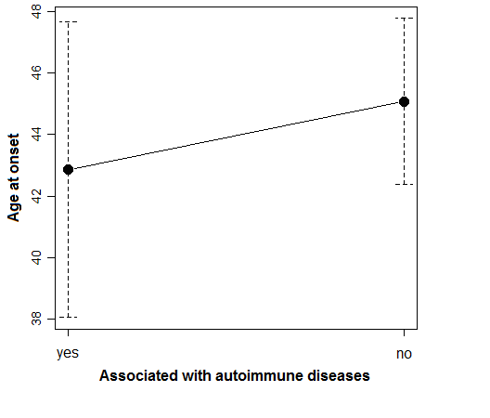
Fig. 1 Age at onset according to the association with autoimmune diseases

Write what's wrong in the above chart (if applicable):

d) Review the chart below :

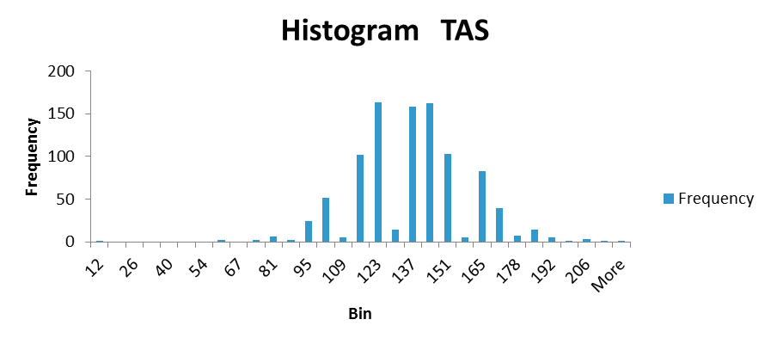

Write what's wrong in the above chart (if applicable):

e) Evaluate the following table:
Table no. 3 Distribution of variable digital ulcers
 | No.. | % (95% CI) | Total cholesterol (mg/dl)
yes | 72 | 57.143% (48024-65918) | 181.3 (32.1) (mg/dl)
no | 54 | 4 0 .857% (34082-51976) | 196.4 (27.3) (mg/dl)

Write what's wrong in the above table (if applicable):

f) Specify the errors (if any) contained by the following statements found in chapter Results of an article: "The average systolic blood pressure of subjects in the group treated with enalapril is 135 mmHg. This result is extraordinary. The values found in literature are of 150 mmHg [19] or 173 [20] mmHg in similar situations. "

g) Specify the errors (if any) contained by the following statements found in chapter Material and methods of an article: "The blood pressure of the studied subjects was measured with a mercury column sphygmomanometer. This was done since digital sphygmomanometers are not reliable. "

h) Specify the errors (if any) contained by the following statements found in chapter Introduction of an article: "The aim of the study is to assess the effectiveness of clofibrate compared with placebo in patients with familial hypercholesterolemia. Hypercholesterolemia is an important issue because it can lead to atherosclerosis. In literature we found average values of 233 mg/dl for total cholesterol, respectively 256 mg/dl for subjects treated with clofibrate."

Conclusion of this activity:
Today’s activity helps you to rehearse basic knowledge of medical research methodology, which in turn helps you:

- to perform the research for your graduation thesis
- to answer clinical questions and to practice evidence based medicine/dentistry (E.B.M. / E.B.D.)
- to understand and critically appraise academic papers that you will read as part of your continuous medical education (C.M.E.)
- to understand and critically appraise oral presentations at congresses and other conferences that you will attend as part of your continuous medical education (C.M.E.)

Save the changes you made to this document, and then close it.
Attach the PowerPoint document to an e-mail message and send it to the address provided by your assisting professor. The e-mail Subject should specify: Your full name, your group and the title of this activity.

