# TO DO: Practical activities. Searching in bibliographic databases

## Aims and benefits of this practical activity

* Performing a scenario based search/ medical question using the PICO method
* Creating a search strategy to identify a manageable number of articles on a certain research topic using MeSH
* Searching MEDLINE/PubMed via [PICO](https://pubmedhh.nlm.nih.gov/nlmd/pico/piconew.php)
* Using *Clinical Queries* and search restrictions by certain criteria offered in PubMed (e.g. by article type, year of publication, etc.)
* Acquiring the skills for writing references in the Vancouver style standard
* Creating a bibliographic record file with a table of contents, to easily retrieve items of interest by title
* Aquiring bibliographic documentation skills for research and current practice.
* Understanding the meaning of the bibliometric indices of journals (WOS = Web of Science): FI (impact factor) and Q (quartile)
* Understanding the meaning of researchers' bibliometric indices: Hirsh index (WOS), i10 (Google Scholar)

*Clinical Queries* allows the search for clinical studies according to their type: therapy, diagnostic, prognostic (risk factors).

## Searching for Therapy information - Examples

**Scenario:** You are interested in the usefulness of betablockers in heart failure.  
**Clinical Question:** In *Heart Failure*, Is *Bisoprolol* more effective than *Carvedilol* for the reduction of patient *Mortality*?

We will use the **PICO** technique, as presented below:

|  |  |
| --- | --- |
| **P** - patient/problem to be solved (usually the name of the disease) | *Heart failure* |
| **I** - intervention of interest (e.g. a drug/medication) | *Bisoprolol* |
| **C** - comparison (e.g. another drug/medication) | *Carvedilol* |
| **O** - outcome of interest /objective (e.g. reduction of mortality) | *Mortality* |

**A. MeSH**

1. We access the resource of interest <https://www.ncbi.nlm.nih.gov/mesh/>

2. We are looking for the first PICO component, namely Heart failure. It is recommended to choose from the suggested list:

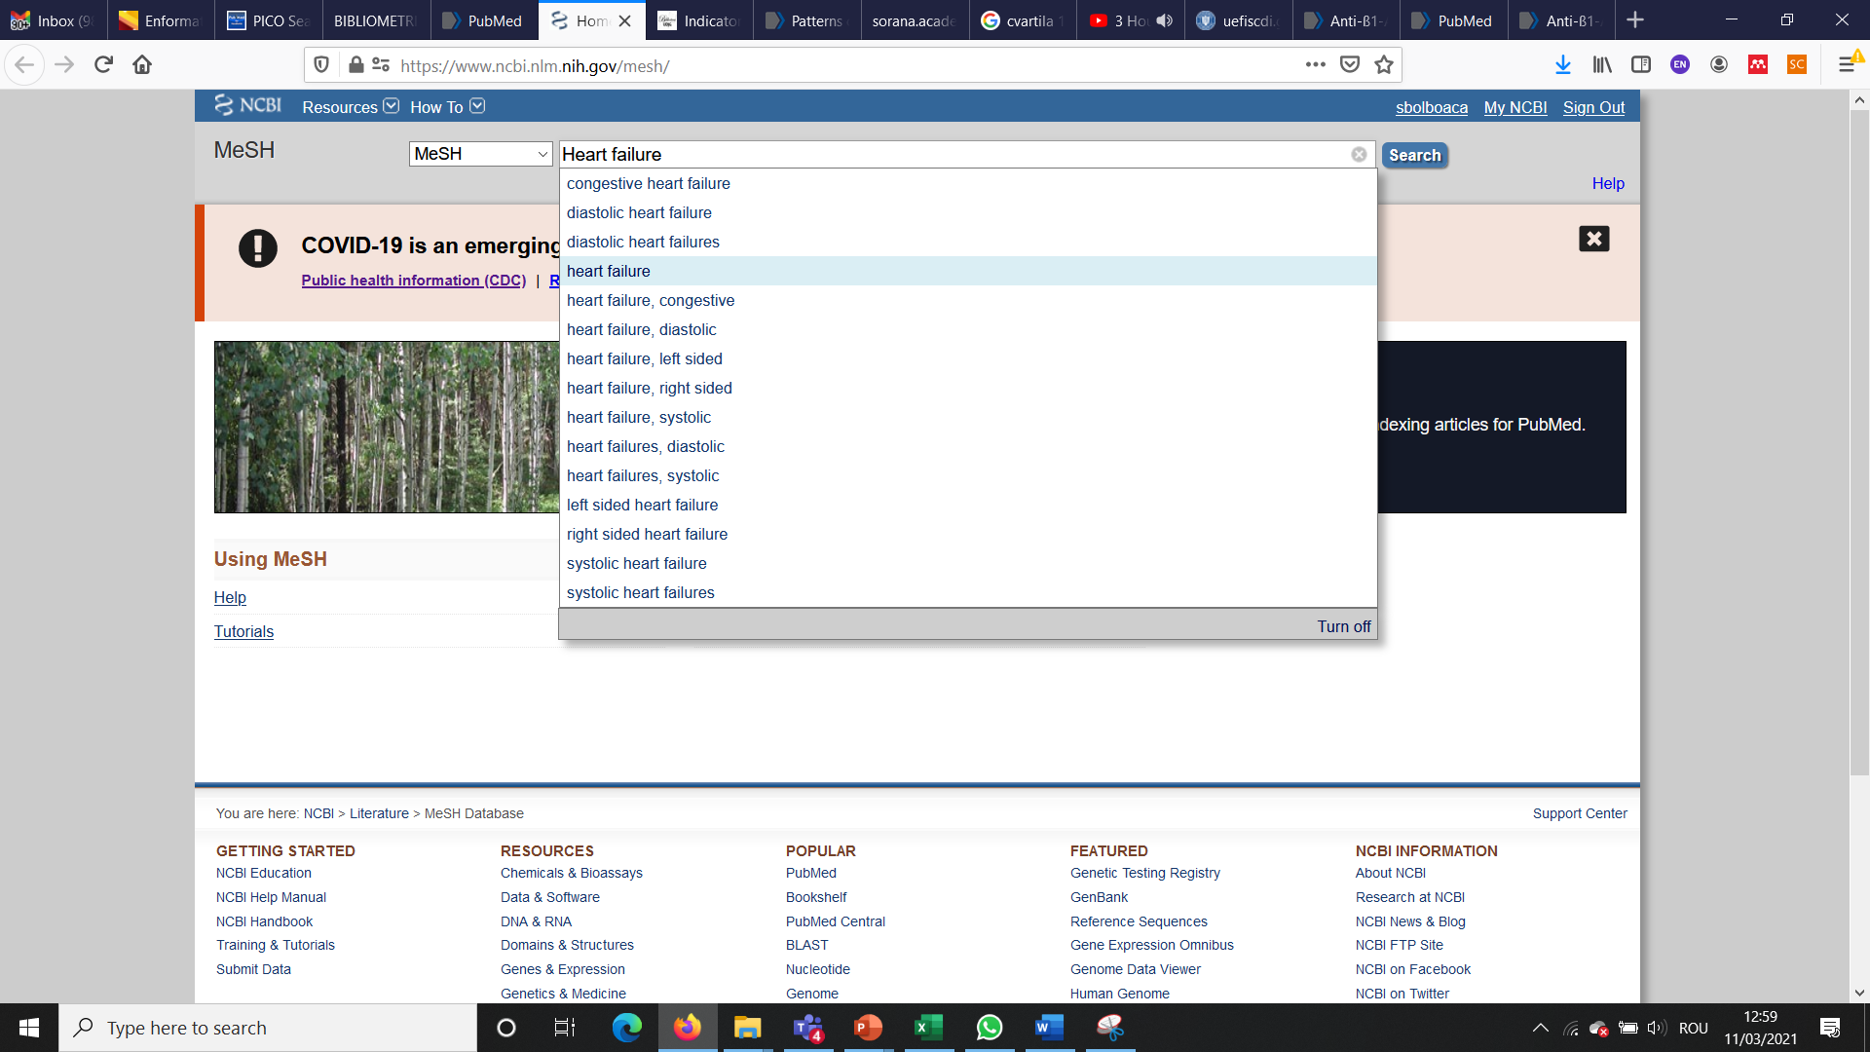

# 3. Select the word of interest and click add to search builder:

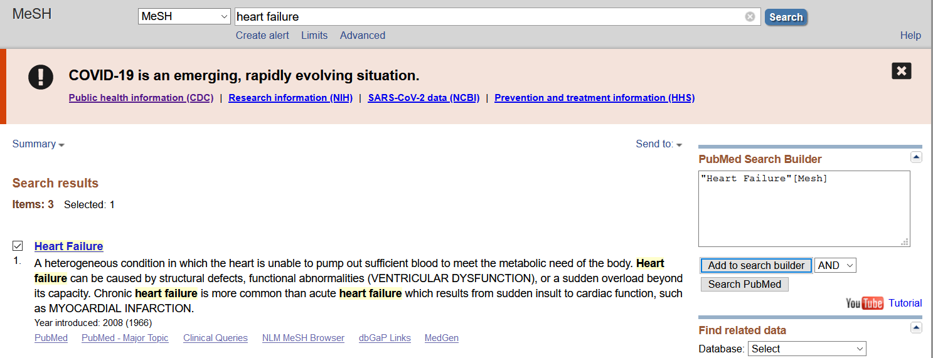

4. We proceed similarly with the other PICO components. When we have in PubMed Search Builder all the PICO components we will search in PubMed by accessing the Search PubMed option.

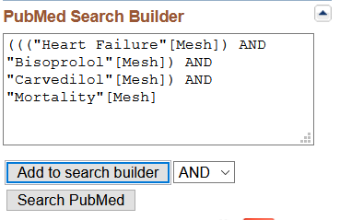

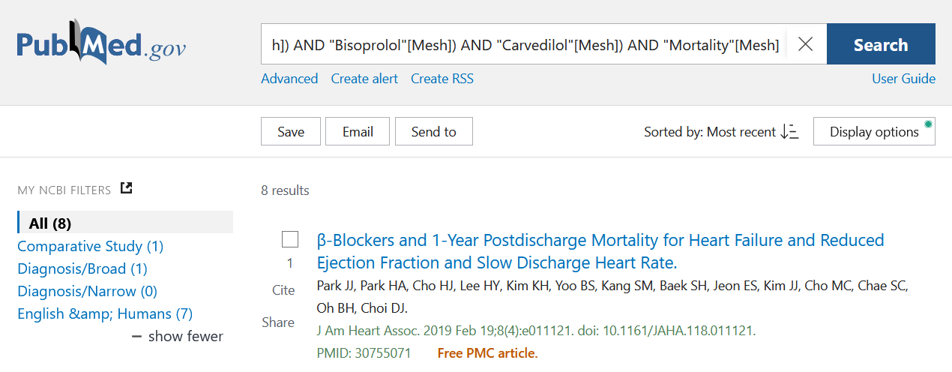

|  |
| --- |
| Park JJ, Park HA, Cho HJ, Lee HY, Kim KH, Yoo BS, et al. β-Blockers and 1-Year Postdischarge Mortality for Heart Failure and Reduced Ejection Fraction and Slow Discharge Heart Rate. J Am Heart Assoc. 2019 Feb 19;8(4):e011121. doi: 10.1161/JAHA.118.011121. PMID: 30755071; PMCID: PMC6405672. |

5. The reference of the most recent article is the following (March 11, 2021):

* We have an article in an Open Access journal (we know this because we have PMCID which is the PCM identifier providing access to full text!)

**B. PICO/PubMed**

1. We access the resource of interest <https://pubmedhh.nlm.nih.gov/nlmd/pico/piconew.php>

2. Write down the PICO strategy

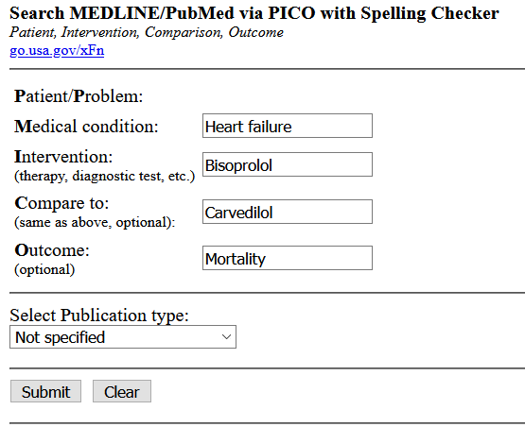

Number of result: 163

First page of 9

3. Results

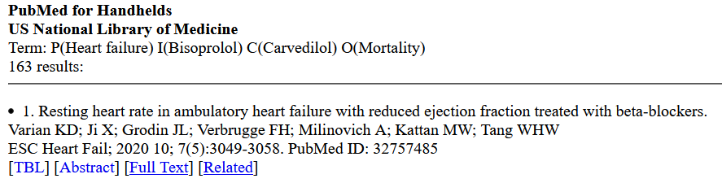

TBL = conclusion

Abstract = shortcut to abstract

Full text = access to full text

Related = similar articles

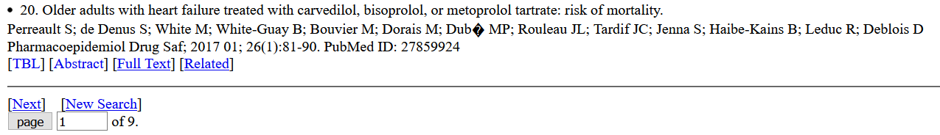

4. Narrow your search to Clinical Trials

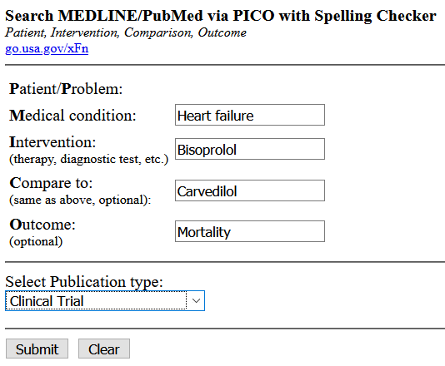

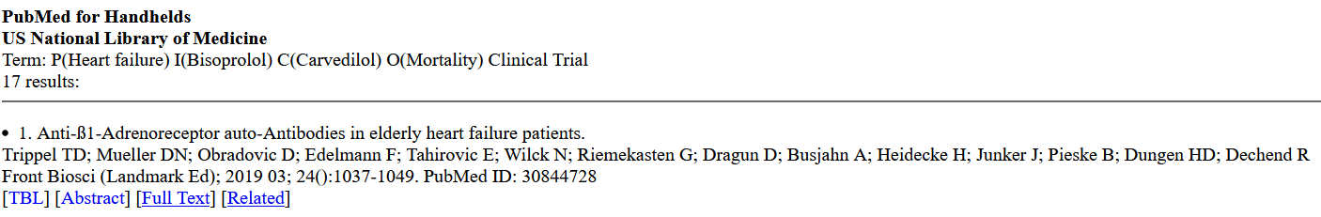

5. The reference of the most recent article is the following (March 11, 2021):

|  |
| --- |
| Trippel TD, Mueller DN, Obradovic D, Edelmann F, Tahirovic E, Wilck N, et al. Anti-ß1-Adrenoreceptor auto-Antibodies in elderly heart failure patients. Front Biosci (Landmark Ed) 2019;24:1037-1049. |

6. Meaning of PubMed ID: 30844728 = PubMed identifier

**C. Clinica Queries**

1. We access the resource of interest <https://www.ncbi.nlm.nih.gov/pubmed/clinical>

2. We write the search syntax: round brackets have the role of grouping the terms of interest

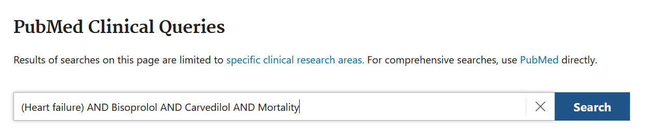

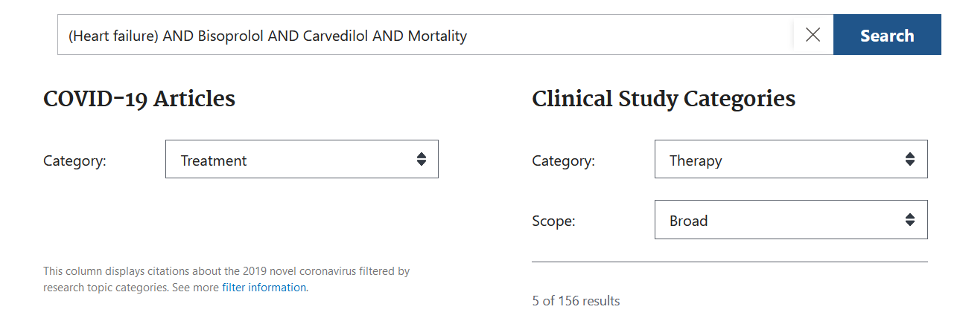

Showing the first 5 results of a total of 156

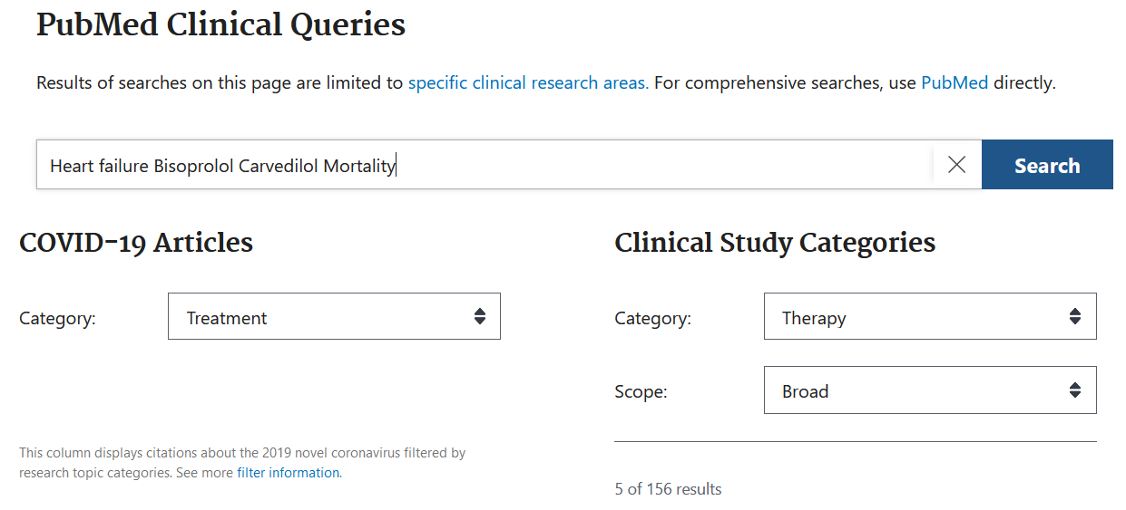

3. We access all the results by clicking on **See all** which takes us to the PubMed interface

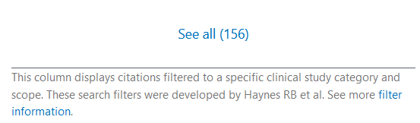

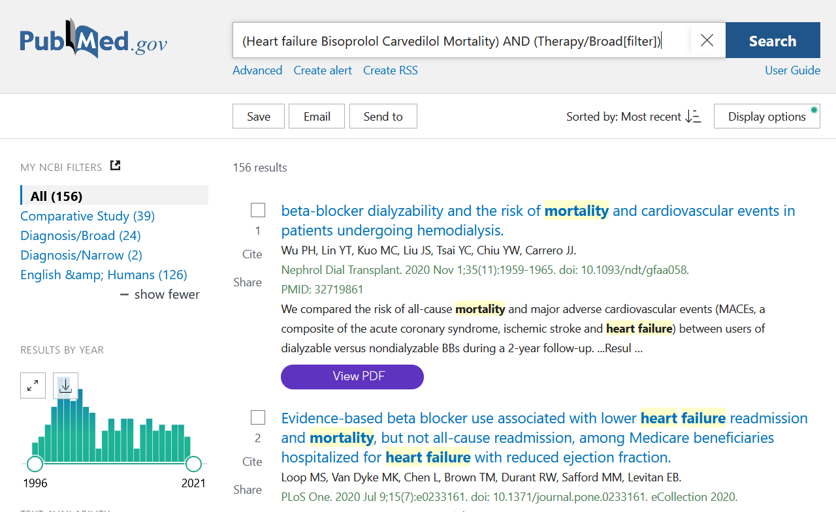

4. In PubMed we can refine the search depending on the type of article, the date of publication, species (human / animal), the language in which the article was published, the age of the patients, etc.

Refining the search: articles published in English, on human subjects, in the last 10 years, only clinical studies show

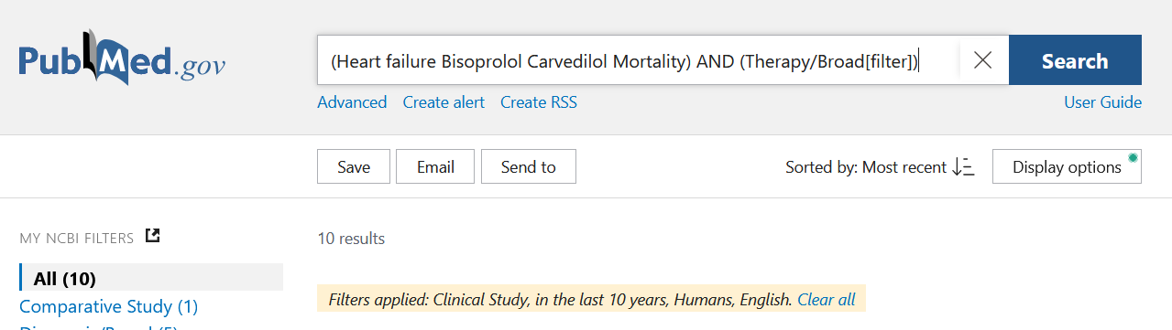

5. The reference of the most recent article is the following (March 11, 2021):

|  |
| --- |
| Trippel TD, Mueller DN, Obradovic D, Edelmann F, Tahirovic E, Wilck N, et al. Anti-ß1-Adrenoreceptor auto-Antibodies in elderly heart failure patients. Front Biosci (Landmark Ed). 2019;24:1037-1049. PMID: 30844728. |

## Searching for Therapy information

**Scenario:** You are interested to find out which of two possible treatments for *type 2 diabetes mellitus* (*insulin* or *hypoglycemic agents*) does not affect the *body weight* of treated patients.

1. Write the PICO components for this scenario in the table below:

|  |  |
| --- | --- |
| **P** |  |
| **I** |  |
| **C** |  |
| **O** |  |

1. Perform the above search, using the resources available at <https://www.ncbi.nlm.nih.gov/mesh/>

A.Write the number of articles this resource gives you access to:

|  |
| --- |
|  |

B.Write the reference of the most recent article in Vancouver style:

|  |
| --- |
|  |

1. Perform the above search <https://pubmedhh.nlm.nih.gov/nlmd/pico/piconew.php> , then answer the following questions:
2. Write the number of items identified by the search. when using the ***Therapy*** category and a ***Broad*** scope:

|  |
| --- |
|  |

1. Write the reference of the most recent article in Vancouver style:

|  |
| --- |
|  |

4. Perform the above search <https://www.ncbi.nlm.nih.gov/pubmed/clinical> , then answer the following questions:

A. Write the number of items identified by the search when using the ***Therapy*** category and a ***Broad*** scope:

|  |
| --- |
|  |

B. Write the number of items identified by the search when using the ***Therapy*** category and a ***Narrow*** scope:

|  |
| --- |
|  |

C. Further refine your search in the ***Therapy*** category with ***Narrow*** scope by applying the following criteria:

Languages = English

Species = Humans

Publication dates = last 10 years

Text availability = Free full text

C.1. Write the number of items identified after applying the criteria in point C:

|  |
| --- |
|  |

C.2.Write the Vancouver-style reference for the most recent item among those identified in the previous point:

|  |
| --- |
|  |

5. Which of the three resources do you think is most friendly and best for identifying items of interest? Argue the answer/

|  |
| --- |
|  |

## Searching for Diagnostic information

**Scenario:** You wish to find the better of two imaging methods to diagnose colorectal cancer (*Colorectal Neoplasms*).

**Clinical question:** Is *Computed Tomography* more sensitive (*Sensitivity*) compared to *Magnetic Resonance Imaging* in the diagnosis of C*olorectal Neoplasms*?

1. Write the PICO components for this scenario in the table below:

|  |  |
| --- | --- |
| **P** |  |
| **I** |  |
| **C** |  |
| **O** |  |

1. Perform the above search, using the resources available at <https://pubmedhh.nlm.nih.gov/nlmd/pico/piconew.php>.

Write the number of articles this resource gives you access to:

|  |
| --- |
|  |

1. Perform the above search on <https://www.ncbi.nlm.nih.gov/pubmed/clinical>, then answer the following questions:
2. Write the number of items identified by the search when using the ***Diagnosis*** category and a ***Narrow*** scope:

|  |
| --- |
|  |

1. How many of these results are systematic reviews?

|  |
| --- |
|  |

1. Write the Vancouver-style reference for the most recent item among those identified in the previous point:

|  |
| --- |
|  |

## Searching for information on Prognosis / Ethiology and risk factors

**Scenario**: A 38 years old future mother (*mother age*) asks you for a precise *risk* estimate that her future child could suffer of trisomy 21 (*Down syndrome*).

1. Write the PICO components for this scenario in the table below:

|  |  |
| --- | --- |
| **P** |  |
| **I** |  |
| **C** |  |
| **O** |  |

1. Perform the above search, using the resources available at <https://pubmedhh.nlm.nih.gov/nlmd/pico/piconew.php>.

Write the number of articles this resource gives you access to:

|  |
| --- |
|  |

1. Perform the above search on <https://www.ncbi.nlm.nih.gov/pubmed/clinical>, then answer the following questions:
2. Write the number of items identified by the search when using the **Prognosis** category and a ***Narrow*** scope:

|  |
| --- |
|  |

1. Write the Vancouver-style reference for the article entitled *Are paternal or grandmaternal age associated with higher probability of trisomy 21 in offspring? A population-based, matched case-control study, 1995-2015* (<https://pubmed.ncbi.nlm.nih.gov/33258505/>):

|  |
| --- |
|  |

## Searching for information in books and treatises

Utility: to answer general medical questions

Disadvantages: Information is potentially obsolete, even if the books or treatises have been published recently.

To search for existing books and treatises in the UMF Cluj library you can access the library search engine at: <http://www.liberty.umfcluj.ro>

**Scenario:** You want to conduct your graduation thesis at the Department of *Microbiology*. To get an overview on several aspects in this area in order to discuss them with your future thesis coordinator, you've been looking for a comprehensive microbiology book to update your knowledge in that domain. The coordinator told you that an appropriate source would be the most recent one in the library.

**Search Technique:**

A. Access the search engine of the UMF Cluj library: <http://www.liberty.umfcluj.ro>

B. The word of interest is microbiology and its location is in the title

C. Write the number of obtained results:

|  |
| --- |
|  |

D. sort by descending year

E. Write the Vancouver-style reference to one of the latest books in the library:

|  |
| --- |
|  |

## Bibliometric indices: journals

Scenario: We want to identify an ISI journal to read about the effectiveness of antiretroviral therapies in the treatment of HIV (human immunodeficiency virus) infection. We have access to the following information:

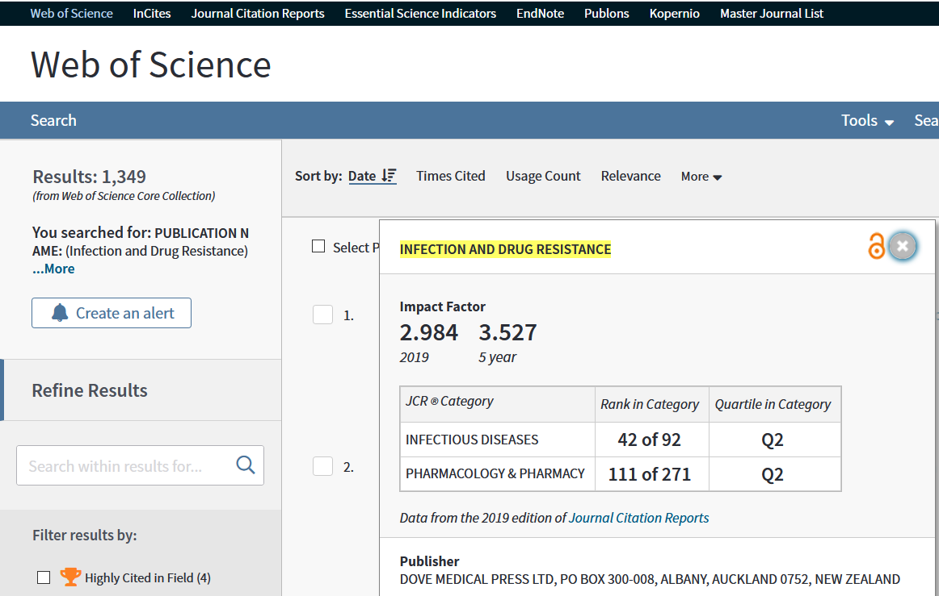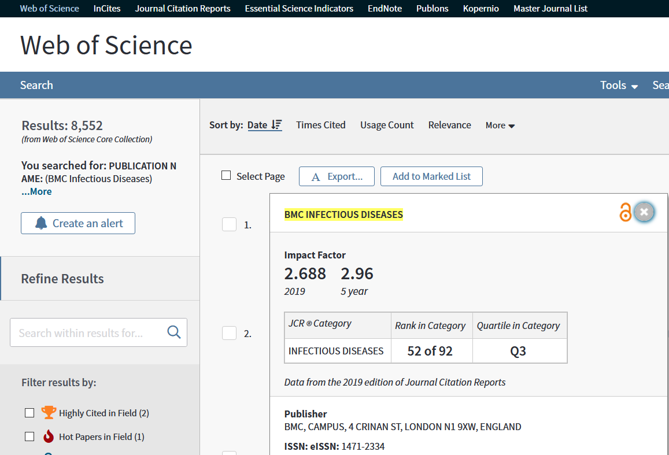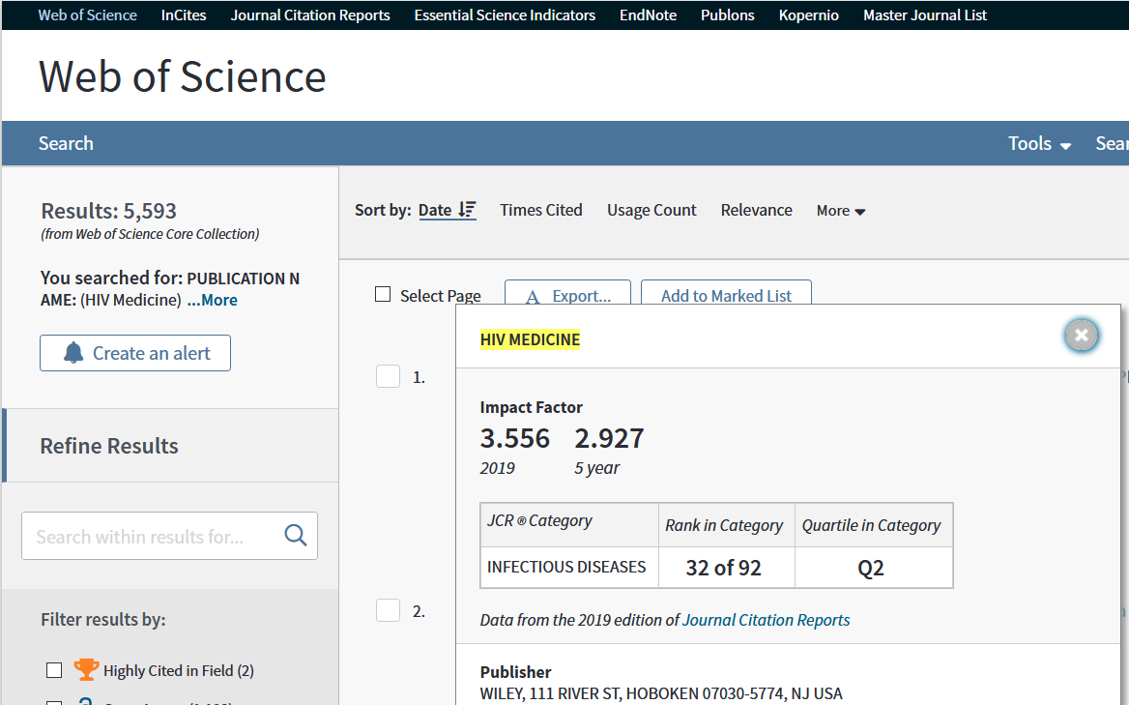

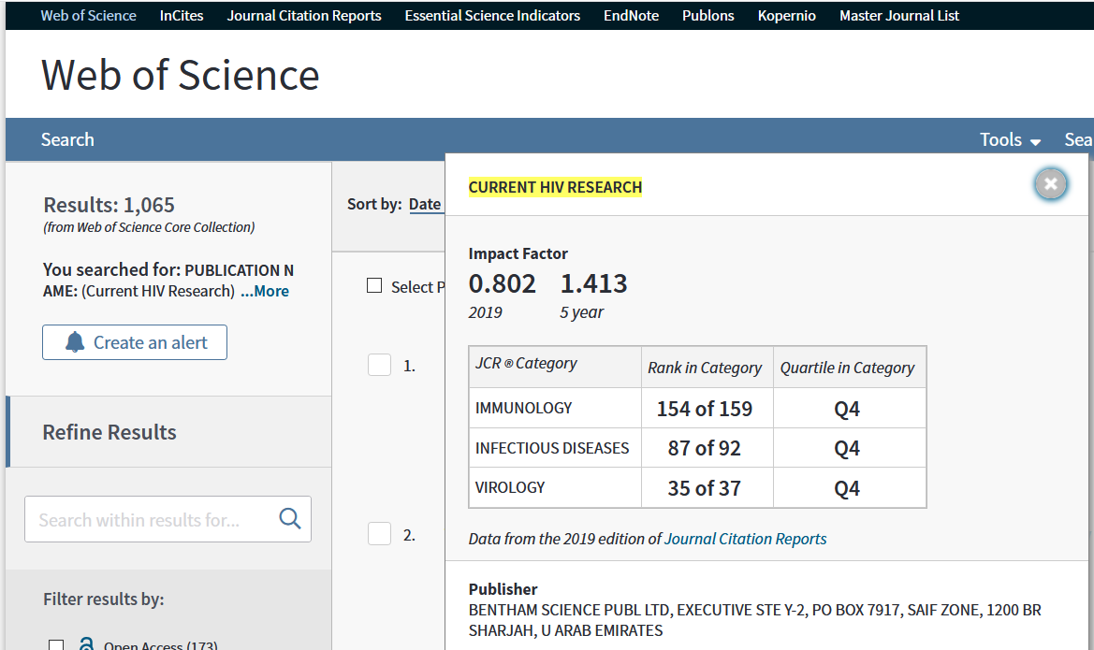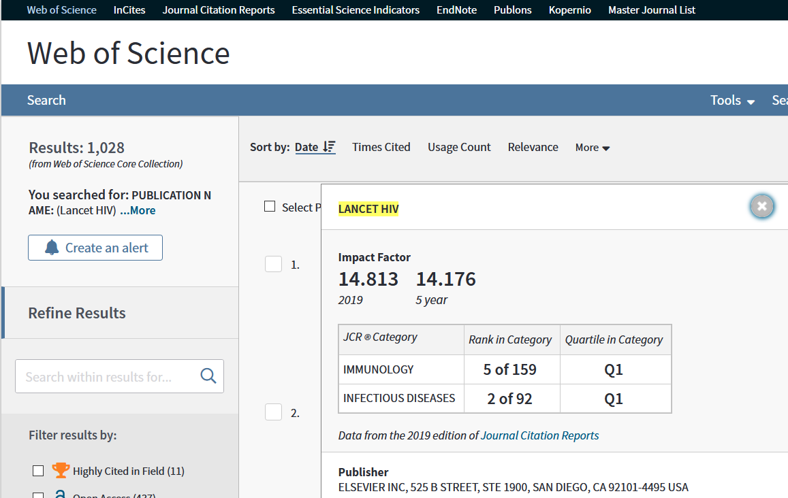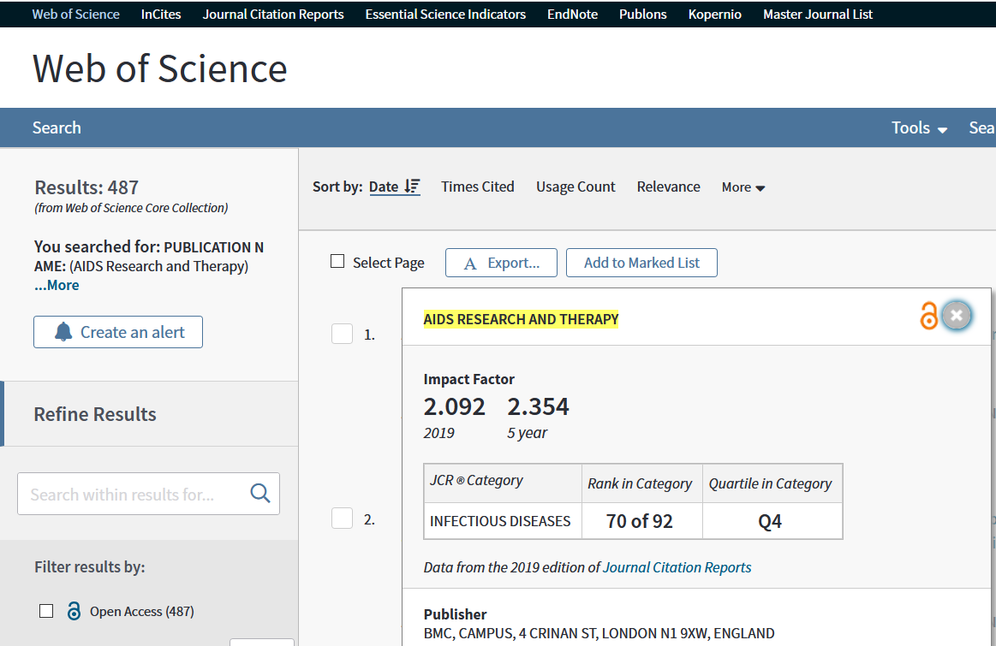

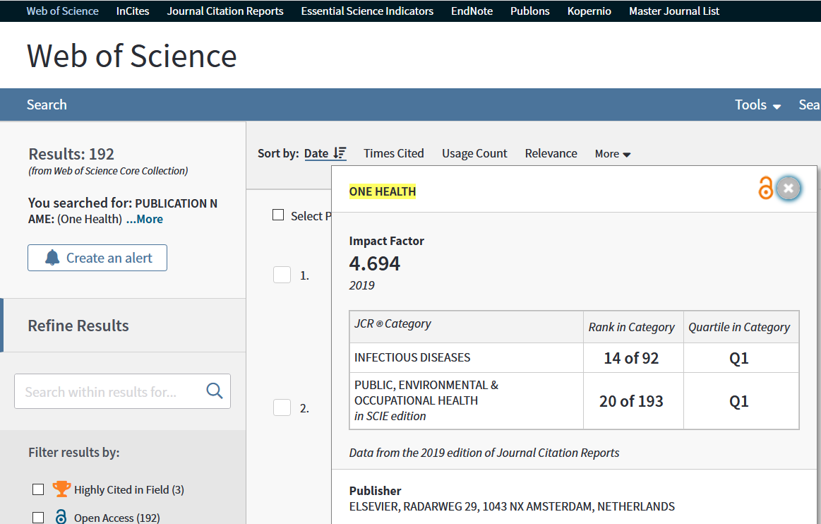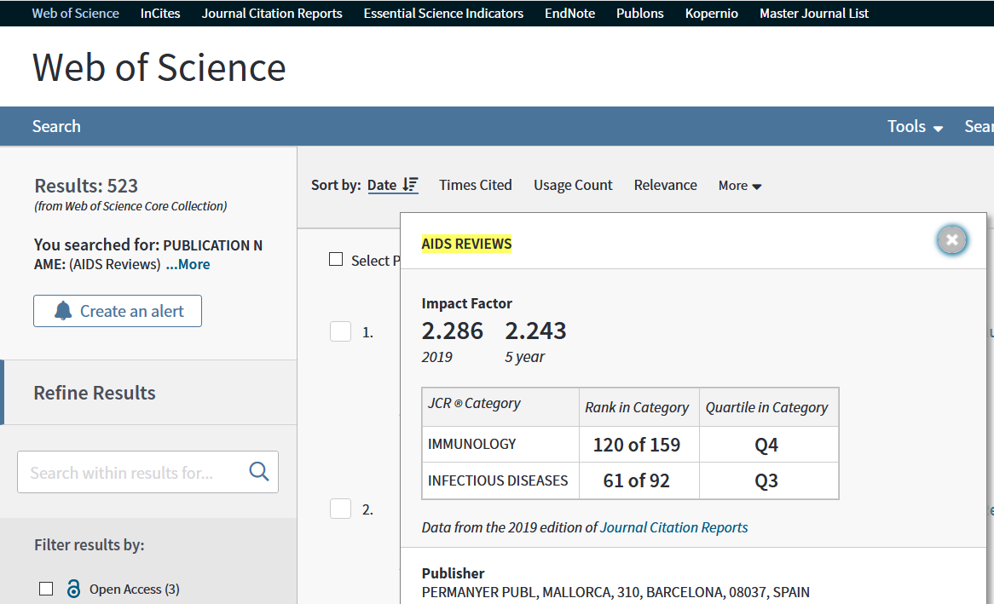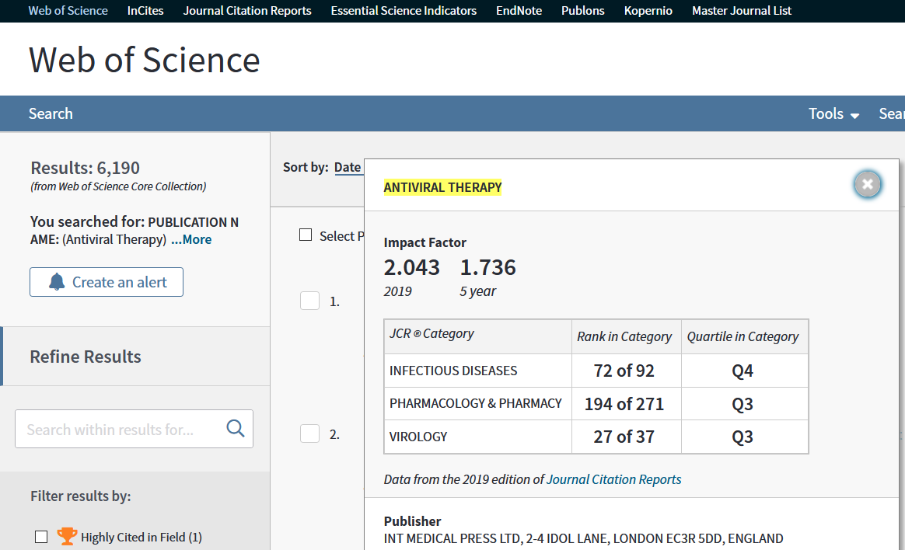

The information in the previous images along with other data has been summarized in the table below:

|  |  |  |  |  |
| --- | --- | --- | --- | --- |
| **Journal** | **No. articles 2019** | **FI2019** | **Rank (domain/field)** | **Q** |
| Infection and Drug Resistance | 15163 (12048a+3115b) | 2.984 | 111/271 (Pharmacology & Pharmacy) | Q2 |
| BMC Infectious Diseases | 38040 (33384a+4656b) | 2.688 | 52/92 (Infectious Diseases) | Q3 |
| HIV Medicine | 3341 (3027a+ 314b) | 3.556 | 32/92 (Infectious Diseases) | Q2 |
| Current HIV Research | 3201 (1681a+1520b) | 0.802 | 35/37 (Virology) | Q4 |
| Lancet HIV | 3003 (1599a + 1404b) | 14.813 | 2/92 (Infectious Diseases) | Q1 |
| AIDS Research and Therapy | 1661 (1148a+513b) | 2.092 | 70/92 (Infectious Diseases) | Q4 |
| One Health | 1417 (823a+594b) | 4.694 | 20/193 (Public, Environmental & Occupational Health) | Q1 |
| AIDS Reviews | 1307 (552a+755b) | 2.286 | 120/159 (Immunology) | Q4 |
| Antiviral Therapy | 512 (437a+75b) | 2.043 | 194/271 (Pharmacology & Pharmacy) | Q3 |
| a articole original; b reviews ; FI = factor de impact | | | | |

A. Journals from how many domains/fields are presented in the table above?

|  |
| --- |
|  |

B. How many journals are indexed in the field of Infectious Diseases?

|  |
| --- |
|  |

C. What is the field with the most journals?

|  |
| --- |
|  |

D. What is the journal with the most review articles?

|  |
| --- |
|  |

E. Write the name of the journal with the lowest impact factor:

|  |
| --- |
|  |

F. Write the name of the journal with the highest impact factor:

|  |
| --- |
|  |

G. Write the name of the Q1 Journals:

|  |
| --- |
|  |

H. Write the name of the Q2 Journals

|  |
| --- |
|  |

I. Write the name of the Q3 Journals:

|  |
| --- |
|  |

J. Write the name of the Q4 Journals:

|  |
| --- |
|  |

## Bibliometric indices: researchers

Scenario: We want to see the performance of researchers investigating the effectiveness of antiretroviral therapies (ART) in the treatment of HIV infection (human immunodeficiency virus). We have the following information:

|  |  |  |  |  |  |  |  |
| --- | --- | --- | --- | --- | --- | --- | --- |
| **Researcher** | **WOS** | | **Scopus** | | **Google Scholar** | | |
| **No. of articles** | **h-index** | **No. of articles** | **h-index** | **No. of citations** | **h-index** | **i10** |
| Angela M. Bengtson | 42 | 9 | 50 | 9 | 487 | 13 | 21 |
| Julia del Amo | 180 | 41 | 188 | 40 | n/a | n/a | n/a |
| Paul E. Sax | 274 | 49 | 304 | 53 | 20810 | 65 | 179 |
| Kassem Bourgi | 23 | 6 | n/a | n/a | n/a | n/a | n/a |
| Andrew E. Grulich | 527 | 65 | 449 | 68 | 27137 | 87 | 341 |
| n/a = not available | | | | | | | |

A. Write in your own words what you mean by researcher Andrew E. Grulich's h-index WOS:

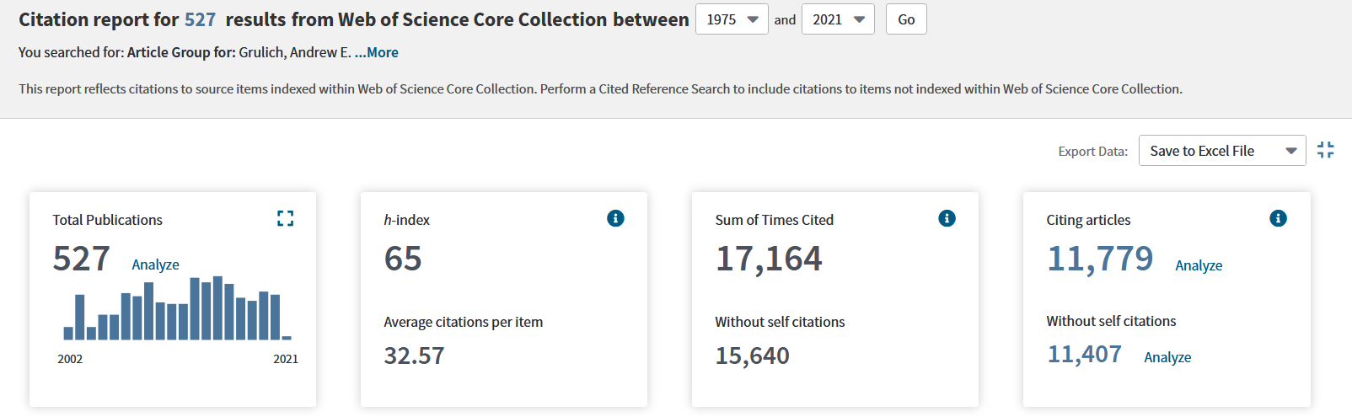

|  |
| --- |
|  |

B. Write in your own words what you mean by the i10 of researcher Andrew E. Grulich:

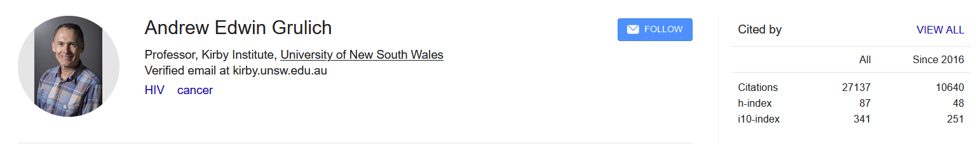

|  |
| --- |
|  |

C. Write in your own words what you mean by the h-index Scopus of researcher Andrew E. Grulich?

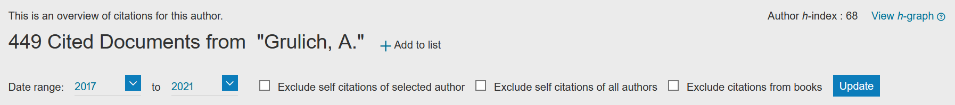

|  |
| --- |
|  |

D. Write in words what you mean by the h-index excluding the self-citations (Scopus) of the researcher Andrew E. Grulich?



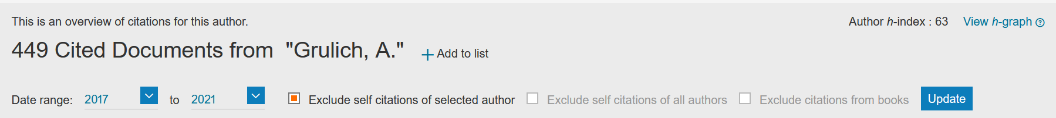

|  |
| --- |
|  |

E. Write in words what you mean by the WOS h-index of researcher Kassem Bourgi?

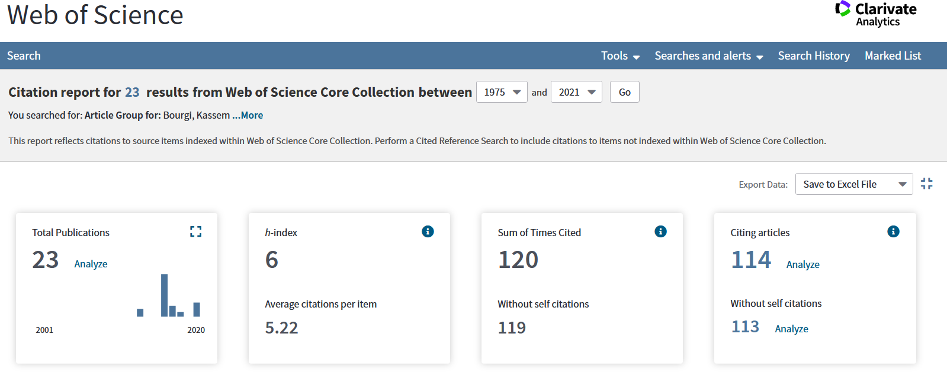

|  |
| --- |
|  |

F. How do you explain the difference between the WOS h-index and Scopus for researcher Paul E. Sax?

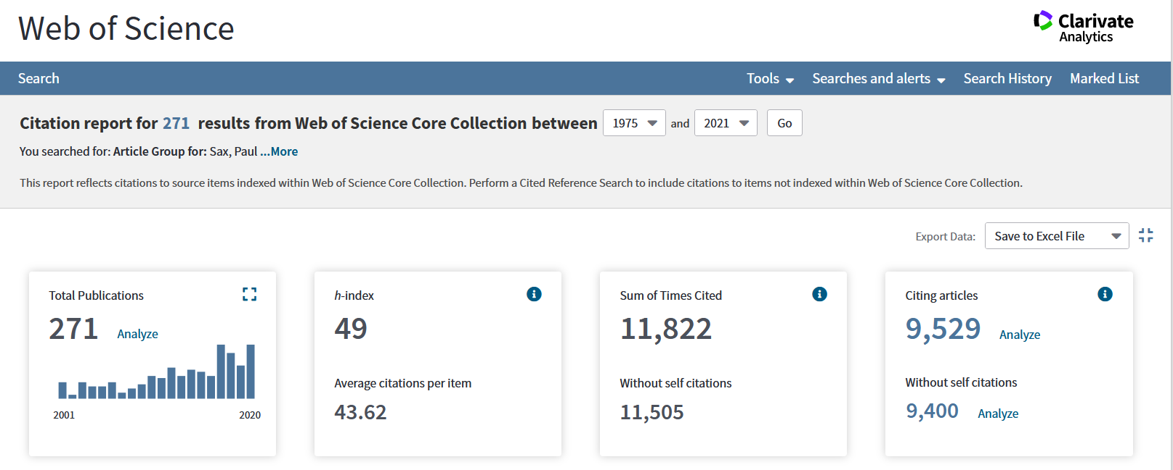

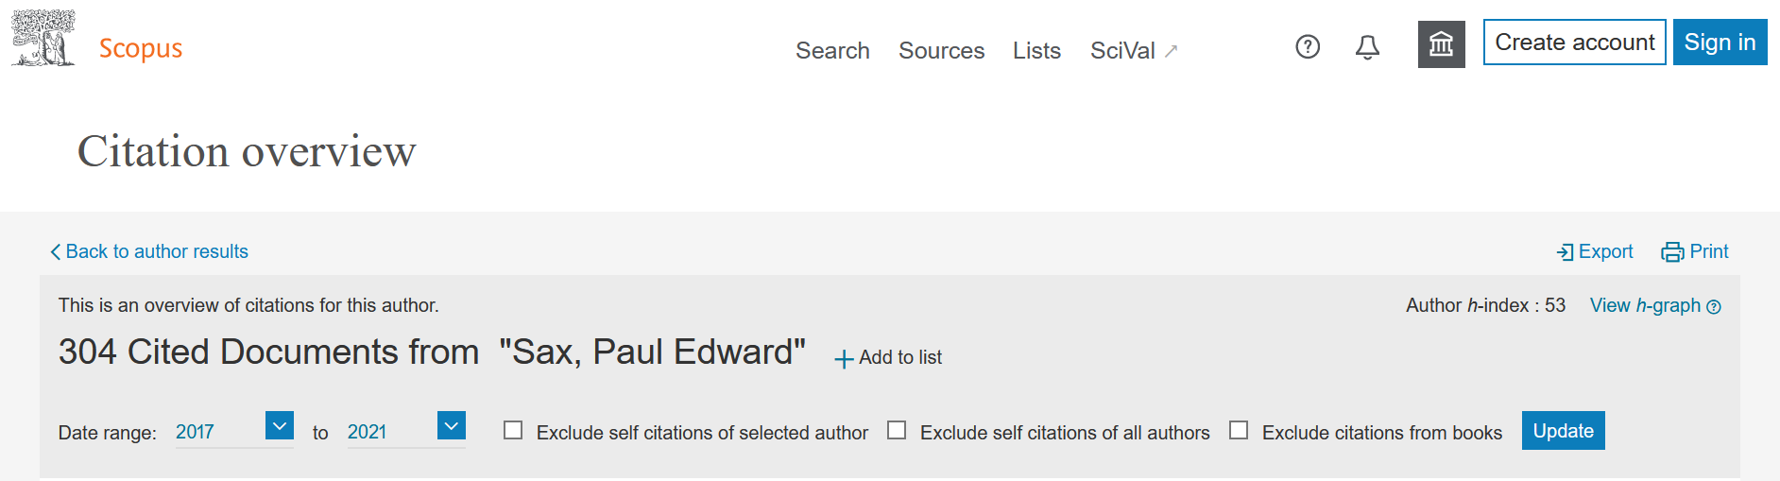

|  |
| --- |
|  |

**Optional Exercices:**

## Citing other resources in Vancouver style

1. Write down the Vancouver-style reference of the book available at: <https://www.ncbi.nlm.nih.gov/books/NBK567274/>

Kerr A, Chekar CK, Ross E, Swallow J, Cunningham-Burley S. Personalised cancer medicine: Future crafting in the genomic era [Internet]. Manchester (UK): Manchester University Press; 2021 [cited 2021 Mar 9]. Available from: <https://www.ncbi.nlm.nih.gov/books/NBK567274/>

|  |
| --- |
|  |

1. Write down the Vancouver-style reference of the book chapter available at: <https://www.ncbi.nlm.nih.gov/books/NBK11782/>

Kerr A, Chekar CK, Ross E, Swallow J, Cunningham-Burley S. Personalised cancer medicine: Future crafting in the genomic era [Internet]. Manchester (UK): Manchester University Press; 2021 [cited 2021 Mar 9]. Chapter 2, Genomic techniques in standard care: gene-expression profiling in early-stage breast cancer. Available from: <https://www.ncbi.nlm.nih.gov/books/NBK567281/>

|  |
| --- |
|  |

1. Write down the Vancouver-style reference for the next web-page:

<https://www.euro.who.int/en/health-topics/health-emergencies/coronavirus-covid-19/country-overviews>

D'Alessandro DM, D'Alessandro MP. Virtual Pediatric Hospital™: a digital library of pediatric information [Internet]. [Iowa City (IA)]: Donna M. D'Alessandro; c1992-2018 [revised 2021 Jan 1; cited 2021 Mar 9]. Available from: <http://www.virtualpediatrichospital.org>

|  |
| --- |
|  |

1. Write down the Vancouver-style reference for the next web-page:

<https://reference.medscape.com/calculator/685/garfield-af-risk-calculator>

|  |
| --- |
|  |

## Conclusions

* Bibliographic documentation is an essential step both in the preparation and planning of research and in updating medical knowledge that is constantly evolving in the medical field.
* The structured search of the specialized literature can be done with the help of the PICO structure
* Search skills are formed through exercise.
* The citation of the consulted resources is mandatory and in the field of medicine it must respect the Vancouver style.
* In the academic field there are a number of bibliometric indices that need to be known. They are specific to journals and researchers and the same indicator has different values ​​for different databases.

## Take home messages

* The PICO technique is used to create structured search strategies.
* The words used in the search strategy must be correct.
* Bibliographic databases use filters to refine the search.
* The number of results identified in a specific search depends on the number of resources indexed in that database.
* Identifying words of interest can be done with MeSH.
* MeSH allows you to build the PubMed search strategy.
* PICO search is a PubMed search engine that suggests correcting words if they are misspelled
* The search skills of the specialized literature are individual and are formed through exercise.
* The main bibliometric indices for journals are the impact factor and the rank of the journal given by the value of the quartile. WOS indices are used in academic field.
* The main bibliometric indices for researchers are the Hirsh index (WOS) and i10 (Google Scholar).